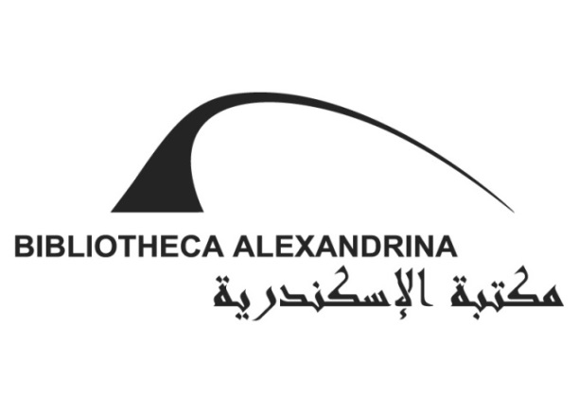

13th Summer International
Festival
30 July − 4 September 2015
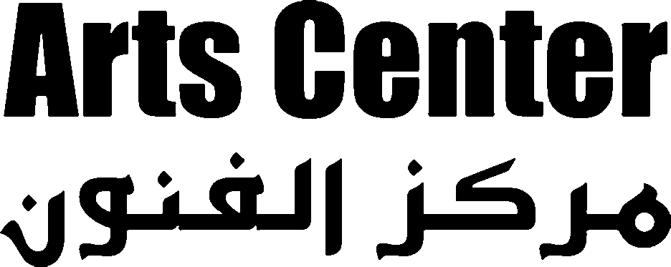

Thursday, 30 July
The Opening Ceremony
Concert: Angham
Open Air Theater; 8:30 pm. Tickets: EGP 200.-, EGP 150.- (seated), EGP 75.- (standing)

Friday, 31 July
Concert: Black Theama Band
Open Air Theater; 8:30 pm. Ticket: EGP 50.-

Saturday, 1 August
Concert: BA Orchestra
Musical Cocktail Concert
Violin Soloist and Conductor: Khaled El Showiekh
Open Air Theater; 8:30 pm. Ticket: EGP 20.-

Sunday, 2 August
Concert: Sherien Yehya
Covers of famous Nagat, Warda, and Um Kulthoum songs
Open Air Theater; 8:30 pm. Tickets: EGP 40.- (seated), EGP 30.- (standing)

Monday, 3 August
Concert: City Band
Open Air Theater; 8:30 pm. Ticket: EGP 20.-

Tuesday, 4 August
Concert: Al-Masrieen Band
Open Air Theater; 8:30 pm. Ticket: EGP 35.-

Wednesday, 5 August
Concert: Mohamed Mohsen
Open Air Theater; 8:30 pm. Ticket: EGP 50.-

Thursday, 6 August
Concert: Zajal Band
Open Air Theater; 8:30 pm. Ticket: EGP 20.-

Theater: The Seven Days
Directed by Islam Awad
The Sawt el-Sharq for Arts Troupe
Small Theater; 8:30 pm. Ticket: EGP 15.- (EGP 10.- for students)

Friday, 7 August
Cinema: Short Film Forum
Lecture Hall; 7:00 pm. Free entry.
A selection of short fiction films produced in 2012 by the Krakow Film Foundation

Concert: Ayamna el-Helwa Band
Open Air Theater; 8:30 pm. Ticket: EGP 50.-

Saturday, 8 August
Concert: Kamilya Jubran (Palestine)
Great Hall; 8:30 pm. Tickets: EGP 75.-, EGP 50.-

Sunday, 9 August
Concert: Cairokee Band
Open Air Theater; 8:30 pm. Ticket: EGP 50.-

Monday, 10 August
Stand-up Comedy: The Comedy Bunch
Open Air Theater; 8:30 pm. Ticket: EGP 40.-

Tuesday, 11 August
Concert: African Music Night
High Dam Band
Open Air Theater; 8:30 pm. Ticket: EGP 20.-

Wednesday, 12 August
Theater: Zamkan (Tunisia)
Open Air Theater; 8:30 pm. Ticket: EGP 15.- (EGP 10.- for students)

Thursday, 13 August
Cinema: Documentary Film Forum
Lecture Hall; 7:00 pm. Free entry.
A selection of short fiction films produced in 2012 by the Krakow Film Foundation

Concert: Ali El Hagar and the BA Orchestra
Open Air Theater; 8:30 pm. Tickets: EGP 50.- (seated), EGP 40.- (standing)

Friday, 14 August
Concert: Jadal Band
Great Hall; 8:30 pm. Tickets: EGP 50.-, 75.-

Saturday, 15 August
Concert: Fathi Salam and Eleonore
Open Air Theater; 8:30 pm. Tickets: EGP 40.- (seated), EGP 30.- (standing)

Sunday, 16 August
Concert: Massar Egbari Band
Open Air Theater; 8:30 pm. Ticket: EGP 50.-

Monday, 17 August
Concert: Hany Shaker
Open Air Theater; 8:30 pm. Tickets: EGP 100.- (seated), EGP 75.- (standing)

Tuesday, 18 August
Concert: The Egyptian Project Band
Open Air Theater; 8:30 pm. Ticket: EGP 40.-

Wednesday, 19 August
Theater: Street Carnival
Directed by Ahmed Saleh
Produced by Al Madina Performing Arts
Open Air Theater; 8:30 pm. Ticket: EGP 15.- (EGP 10.- for students)

Thursday, 20 August
Concert: The Nour Ashour Project and Culture in Harmony Band from USA
Open Air Theater; 8:30 pm. Ticket: EGP 30.-

Friday, 21 August
Concert: Hanan Mady
Open Air Theater; 8:30 pm. Ticket: EGP 50.-

Saturday, 22 August
Concert: Cairo Steps Band (Egypt/Germany)
Open Air Theater; 8:30 pm. Ticket: EGP 50.-

Sunday, 23 August
Concert: Karakeeb Band and Hossam Hosny
Open Air Theater; 8:30 pm. Ticket: EGP 30.-

Monday, 24 August
Concert: Shaware3na Band
Open Air Theater; 8:30 pm. Ticket: EGP 30.-

Tuesday, 25 August and Wednesday, 26 August
Concert: Omar Khairat and the BA Orchestra
Great Hall; 8:30 pm. Tickets: EGP 300.-, EGP 200.-, EGP 150.-, EGP 85.-

Thursday, 27 August
Concert: Basheer Band
Open Air Theater; 8:30 pm. Ticket: EGP 30.-

Friday, 28 August
Family Day
Workshops and Activities for Children
BA Plaza; 2:30 pm.
A Play by the Child and Adolescent Creative Unit
BA Plaza; 7:00 pm.
Ticket (children): EGP 40.- (includes 3 activities and the play)
Ticket (parents): EGP 15.-
Ticket (extra activity): EGP 15.-
Short Animation Films for Children
Lecture Hall; 6:00 pm. Free entry.
A selection of recently-produced short animated films for children.

Saturday, 29 August
Concert: Medhat Saleh
Open Air Theater; 8:30 pm. Ticket: EGP 75.-

Sunday, 30 August
Concert: Dina El Wedidi
Open Air Theater; 8:30 pm. Ticket: EGP 50.-
Monday, 31 August
Concert: Yehya Khalil
Open Air Theater; 8:30 pm. Tickets: EGP 75.- (seated), EGP 50.- (standing)

Tuesday, 1 September
Dance: Ganoub el-Wadi Troupe for Nubian and African Dance
Open Air Theater; 8:30 pm. Ticket: EGP 15.- (EGP 10.- for students)

Wednesday, 2 September
Concert: Ghalia Benali
Open Air Theater; 8:30 pm. Ticket: EGP 50.-

Thursday, 3 September
Concert: Sama3i Band
Open Air Theater; 8:30 pm. Ticket: EGP 25.-

Friday, 4 September
The Closing Ceremony
Concert: Ghada Shbeir (Lebanon)
Open Air Theater; 8:30 pm. Tickets: EGP 100.-, EGP 75.-

