Intel BASEF 2014 Winning Projects

18 Mar 2014
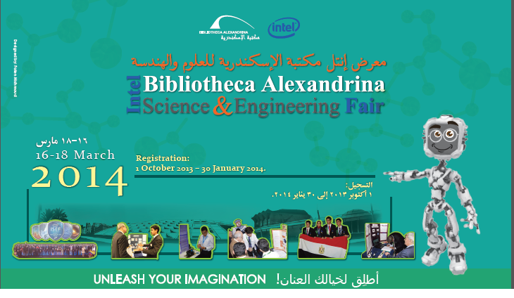

For the 7th year in a row, The Planetarium Science Center (PSC), in collaboration with Intel Co., and the Ministry of Education organized the Intel Bibliotheca Alexandrina Science and Engineering Fair (Intel BASEF), which was hosted by the Bibliotheca Alexandrina (BA) from 16 to 18 March 2014. The event was a success; this year, 122 projects in 16 different categories participated in Intel BASEF; the students competed in all stages with enthusiasm and zest, introducing their creative abilities, scientific thinking, skills, and innovative ideas to the judges and the encouraging audience.
Intel BASEF team has organized three Intel BASEF affiliate fairs within the framework of Intel BASEF 2014 year long program, in El-Nasr Girls College (26-27 Jan.2014), Victoria College (28-29 Jan.2014), and TDC Fair (2 February 2014). In addition to four Affiliate Local Fairs in El Gharbiaa Local Fair (4 February 2014) , Dahklia Local Fair (5 February 2014), Kafr El Sheikh Local Fair (6 February 2014), Alexandria Local Fair (16-18 Feb. 2014).

Many projects participated in Intel BASEF received awards; however, the first three grand awards will represent Egypt in the Intel International Science and Engineering Fair (Intel ISEF) in Los Angeles next May.
- 1st Grand award went to Fares Essam Mohamed Saeed, and Abdel Aziz Ahmed Abdel Aziz Abdel for their project “G-14”.
- 2nd Grand award went to Mona Alsayed Mo3awad, Sara Ezzat Mohamed, Hoda Mamdouh Shuman for their project entitled “Vacuum Evaporator for Water Purification”.
- 3rd Grand award went to Abdallah Mohamed Ahmed, for his project entitled “Employing Pyroelectric Technology to improve the efficiency of Solar Cells panels”.
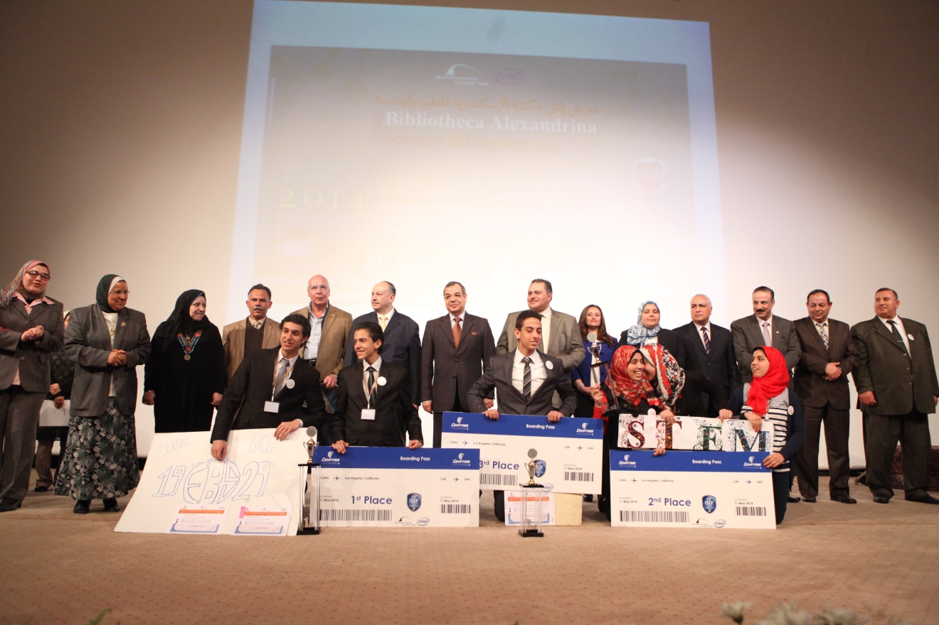Top grand awards winners

Intel BASEF special awards, granted From Intel ISEF Sponsoring Associations:
1- Certificate from The American Psychological Association awarded to BE03 project from El-Gharbia project entitled “ثقافة العشوائيات ام عشوائية الثقافة وتنمية العشوائيات بشريًا”
2- Certificate of Intel Excellence in Computer Science Award, granted to CS03 FROM Alexandria for project entitled “Screening system and identify diseases for travelers (SSIDT)”.
3- Three certificates for the 2014 Regional Ricoh sustainable development award, granted to EV02 project entitled “river cleaning system”.
4- Certificate from American Metrological Society granted to EA01 from Beheira project entitled “المياه الجوفية الصناعية”.
5- Certificate of Most Outstanding Eleventh Grade Exhibit granted from YALE science and Engineering Association, awarded to EE15, project entitled “الاله الذكية”.
6- Certificate from (ASM) awarded to EN02, project entitled “Employing Pyroelectric Technology to improve the efficiency of Solar Cells panels.”
7- Certificate of WOMEN GEOSCIENTIST awarded to EM03, project entitled “extraction biofuel from the desert”.
• Intel BASEF 2014 awards for underage students, including:
- Best Idea Award, granted to Ahmed Usama Mohamed, for his project entitled “fire fighter hydrolytic arm”.
- Best effort Award, granted to Mohammed Ismail Mohamed, for his project “نظرة جديدة للنفايات”.
- Best Presentation Award, granted to Mohamed Aly Abdelsalam Khalefa, for his project “مفترسات ولكن رقيقة”.

• to check Intel BASEF 2014 Best in Category Awards pleased check.

