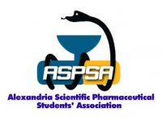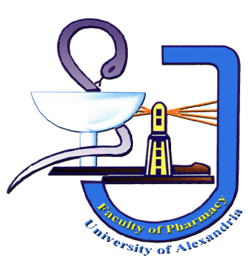Alexandria University
Faculty of Pharmacy
Alexandria Scientific Pharmaceutical Students' Association
ASPSA,
"Pharmacy Education Committee and Public Health Committee"

ASPSA Diabetes Mellitus Campaign
15th – 16th November 2008

Pharmacy students' awareness of diabetes etiology, symptoms, complications & management is a must. In this campaign ASPSA tries to reach this goal.

Suggested Topics:

The First day will handle the nature of the disease:
1 – Opening ceremony with a word by International Diabetes Federation "IDF" and World Health Organization "WHO" representatives discussing: the history of the disease and the incidence and prevalence of the disease and the role of the organizations in improving diabetics' life quality.

2 – Pharmacological aspects of DM including:
Generally: the types, etiology, symptoms & treatment of diabetes.

3 – Recent biochemical investigation of DM including: different types of biochemical tests wish are of importance in diagnosis & control of DM, and types of glucometers.

4 – Student activity in:
* Complication of DM, especially Diabetic foot care and prevention of its amputation.
* Diabetes in children specially etiology & treatment of juvenile diabetes, psychology of diabetic children.

The Second Day will handle the therapeutic lines of DM and pharmacist's role in management of the disease:
1 – Over view of therapeutic strategies of DM "conventional therapeutics"

. Nutrition management and Exercise.
. Insulin therapy in brief.

2 - New Modalities in DM Therapy:
. Islets transplantation.
. Gene therapy.
. Stem cell treatment of Diabetes Mellitus type I&II.

3- Some models for "New Medications and Formulations" in the pharmaceutical market for the treatment of DM.

4- Role of Herbal supplements in management of DM.

5 – Pharmacist role in management of DM discussing the methods of giving right information about the disease to the patients & how to ensure their compliance.

6 – Student activity in:

* Insulin therapy different routes of insulin administration such as oral insulin, insulin inhalers, nasal insulin & insulin pumps, the challenge facing the application of these routes of administration & the strategies to handle challengers will be discussed.

* How to counsel diabetic patients? Introducing the role played in pharmacy by pharmacist & some clinical cases will be discussed.

Campaign duration:

Total 12 hours / 2 days
.
Scientific: 9 hours.

Student activity: 5 hours.

Student activity topics :
1 – complications of DM :
- microvascular .
- macrovascular .
- special care for foot care and glaucoma .

2 – Diabetes in children :
- etiology .
- treatment of juvenile diabetes .
- special care of psychology of diabetic children and counseling of the parents .

3 – Insulin therapy :
-oral insulin.
- nasal insulin.
- insulin inhalers.
- insulin pumps and pens .
- special care for the challenge facing the application of these routes of administration.
- brand and generic pharmaceutical products in the market .

4 – How to counsel diabetic patient :
-what is patient counseling .
- importance of counseling and compliance .
- pharmacist role in diabetic counseling .
- some clinical cases and play showing diabetic counseling to audience .

In closing ceremony there will be:
Presents for the best presenter of the campaign.

Declaration and some Recommendations.

This campaign will be ASPSA first scientific event in this academic year 2008-2009 & many other events will be held also because ASPSA feels the responsibility towards pharmacy students & tries in all ways to improve their scientific level.

Pharmacy Education Committee Chairperson:
Basma El-Nagger.
Public Health Committee Chairman:
Mohamed Ali.

